Population – complete t of values

Parameters — of a population like mean, variance etc

Variable — an element of a population: discrete or continuous

Dichotomous variables : assigned 1 if the variable is present and 0 if it’s not

The Average value of the variable = the probability that the attribute (labelled as 1) is present

Sample – an imperfect representation of the population that is approximately equalto the characteristics of the population

**Sampling methods**

Simple random sampling

* each person is equally likely to be selected
* Other sampling methods may be necessary but also result in samples that include biases
* e.g. when you're trying to study the usage of drugs in a city but males are more closed off about their drug use, you may get a sample that imperfctly represents the population

**Study Designs**

Type 1: studying the exposure before the outcome

-randomized/controlled study design

1. Get a representative sample from a general population under study

2. Randomly assign sample members to exposure groups  
   
 Benefits:  
 reduces self-selection biases (e.g. healther persons are more likely to sign up for a proposed intervention)

-Observational (cohort studies) --> **the individuals self-select to be in exposure groups**

1. Get a representative from the general population under study (A) then ascertain group

2. Get individuals from each group (e.g. smokers and non smokers)

E.g. Observed individuals who did or did-not participate in a needle-exchange programme (of which people got to decide if they wanted to participate or not) and a self-protecting effect from HIV was found in those who partook in the needle exchange programme

Challenges with regard to analysing observational studies:  
 Confounders – factors that are related to both the outcome and exposure of interest --> the association between colds and alcohol consumption (those who drink more alcohol may engage in other activities that bring about colds like smoking)

Type 2: retrospective, studying exposures based on outcomes

Case-Control Study:

* Enrolees are selected on whether they have a rare outcome or not
* Enrolees are then compared to individuals of a control group (which would, optimally, have similar characteristics to case group aside from the studied variable itself)
* Proportion of controls / cases can be varied e.g. 1:1 or 2:1 .....

Challenges:

Potential Confounders  
 Recall bias: Cases and controls may recall exposures differently

**Data Types**

* **Continuous: a 1 unit change in value is constant across the entire range** (mmhg)
* **Binary (a subset of categorical): can only take on 2 values (yes/no)**
* **Categorical data:** 
  + Nominal data: no inherent order to categories E.g. ethnicity
  + Ordinal categorical data: order to categories (e.g strongly disagree to strongly agree)
* **Time to event data:** count data collected over a fixed period of time (total lung cancer cases in a year)
* **Data that are a hybrid of continuous and binary data**: Whether an event occurs and time to the occurrence
  + Time to quitting smoking (yes/no) to getting treatment (Time)

**Module 2 – summarising continuous data measures**

Terms:  
Sample mean, x bar: average of the observations of x in a sample

-best estimate of miu (the population mean)

Median, 50th percentile: not sensitive to influence of extreme sample values

Sample Variance, s^2, average of the square of the deviation from the sample mean:  
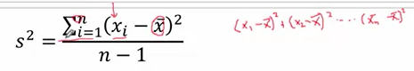

SD, s, on average how far each data point falls from the sample mean

-s can only = 0 if there's no variation at all

Percentiles: pth sample percentile is the value in a sample such that p percent of the sample values <= this value and (100-p) % are larger

**Visualising data**

**Histograms**

-Breaking the data into bins and plotting them to show what **proportion** of the sample falls within a certain range of values

**Boxplots**

Smallest/largest value Or largest non-outlying value

-Large outlier value (75th percentile + 1.5* IQR (diff between 75% and 25%))

-Small outlier value (25th percentile - 1.5* IQR (diff between 75% and 25%))

25th and 75th percentile

Mean

**Common Distributions**

Symmetric and bell-shaped

RIght (positively skewed)

-majority of values are small relative to outliers

-mean tends to be larger than median

Left(negatively skewed)

-majority of values are larger relative to outliers)

-Tail towards to the left

-mean tends to be smaller than median

Uniform

Exceptions / Characteristics:  
- Multiple peaks

**Comparing distributions of Continuous data**

-Numerical Summary:

When comparing more than 2 groups

Designate one group as the reference and compare the means of the rest of the groups to that value

A – D = ...

B – D = ...

C – D = ...

**The normal distribution**

-mean = median = mode

-Defined by a mean and standard deviation

-95 % of all observations fall within +- 1.96 sds of the mean 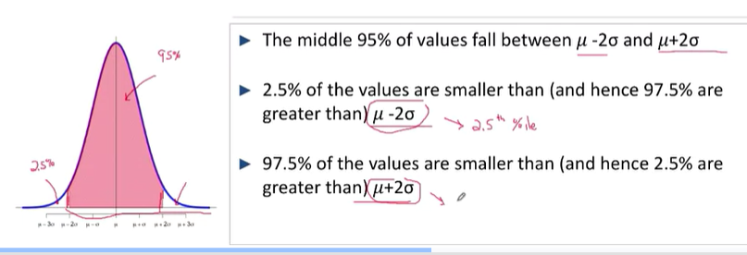

Standardising = (x – xbar )/ sd

**R commands**

Pnorm(1) -- area under the normal curve that is less than 1 sd within the mean

Qnorm(0.95) -- standard deviations you have to go above/below the mean to get a 95% CI

**Binary Data**

Can only take on 2 values, 1 or 0

-Given that it is a discrete distribution, it's variance is given by np^ (1-p^)

-Variability of the sample is based on p^

Sample Proportion, p-hat = # of responders/total individuals in sample

Example, for n = 1000, to gauge if people smoke(1) or not (0)

Sample proportion for yes where there are 200 respondents = 200/1000 = 0.2

And for no = 0.8 (80th percentile onwards = 1)

If we know p^, we have information regarding the sample percentile value

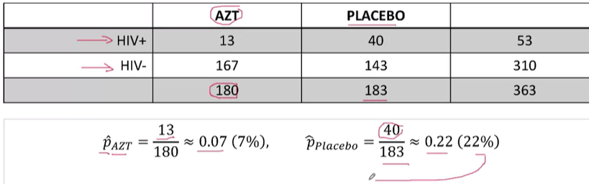

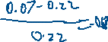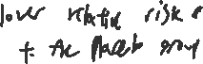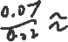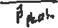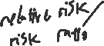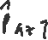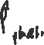

It's possible to see a large diffference with **risk difference and relative risk**

**Odds ratio or relative odds**

*Odds –* (estimated) probability of the event occurring / (estimated) probability of it not occurring

Odds = P^ / (1 –P^)

So as P^ increases, the ODDS increase



Odds ratio = 0.282/0.0752 =3.75

Individuals who received the placebo had 3.75 times the odds of contracting hiv as those who received azt’

Or the azt group has 73% lower odds of contracting HIV

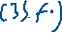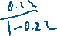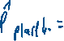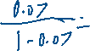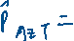

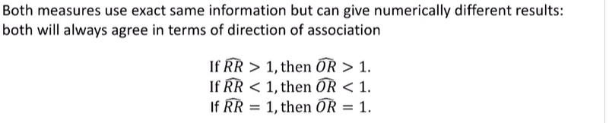

WHy use odds ratio:  
- in Case control studies, the odds ratio is the only measure of association that can be estimated

-in logistic regression, the results are initially presented as odds ratios

**Scaling of ratios**

-Not symmetrical around the value 1

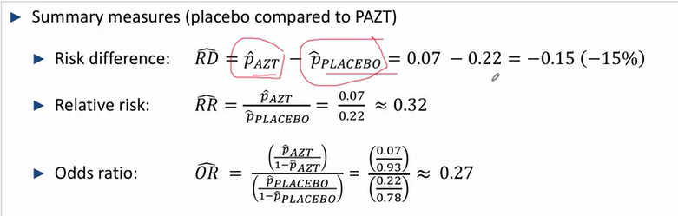

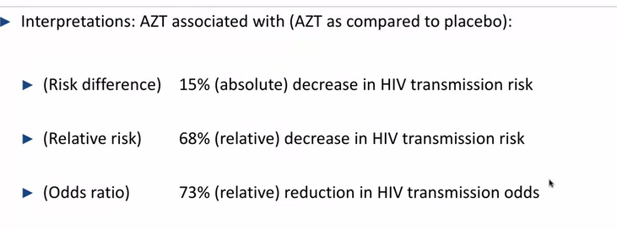

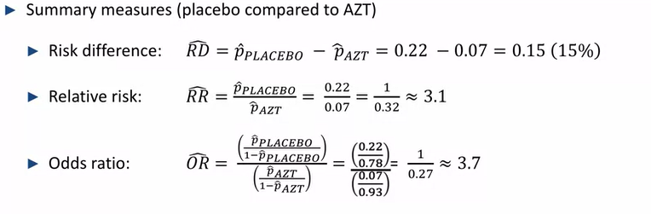

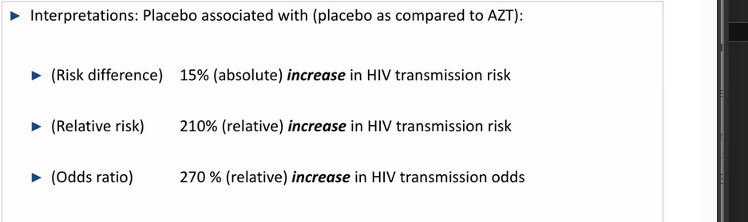



**The range of relative risks (odds ratios and odds) is not the same for big/small and small big (negative and positive associations)  
their ranges are [1,infinity) and (0, 1] respectively

\*\***Therefore, it must be noted that the distribution of odds ratios Is not normal and symmetrically distributed which will affect how we calculate it’s SE (it has to be normalised first)**



This can be rescaled using a **log scale**



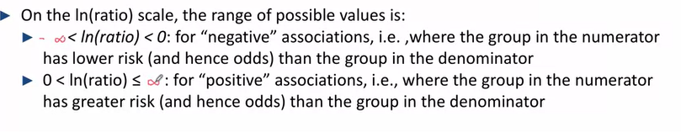



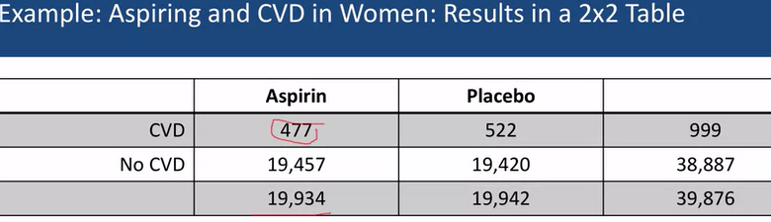

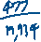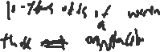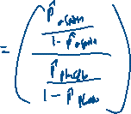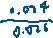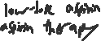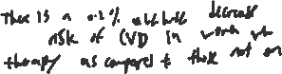

**Adjusted Odds Ratio**

It is often the case that no outcome is affected by 1 and 1 variable only but rather a relationship is determined by a multitiude of factors. For example, the odds of an individual getting cancer can be influenced by not only biological factors such as sex but also vices – like smoking. Therefore, odds ratio mut be calculated for a single variable (such as sex) where we attempt to hold all other variables constant to prevent the effect of confounding. (**Especially important in case-control studies)**

Calculation:

**Time to event data**

*Incidence rate summarises the 2 dimensions of time and whether the event occurred into a single number*

Time-to-event analysis, AKA:

Incidence analysis

Survival analysis

Time to event analysis

Failure time data analysis

**Event times grouped by time intervals** :  
 Event rates for data without exact times known

***Incidence rate:***

***IR***  = cases/persons per year (assuming everyone in the sample was there for say a year) = x cases / y person years

e.g. 10,279 cass of lung cancer in pennsylvania in a year, given 12,281,054 individuals (which in a year translates to 12,281,054 person years)

that's 10279/12281054 = 0.0008 cases / person year   
  
Which is also equal to 8 cases per 10,000 person years in the state of pennsylvania in the year 2002

-a binary outcome but with an element of time

-not exactly a proportion

**Event time data with exact times known**:

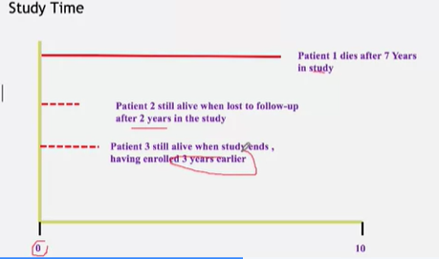

Where the study occured from say 1973 to 1984

The exact occurrence of the event is known e.g. time of death, recover, diagnosis etc.

-Often used in longitudinal studies where individuals are followed along

-Different observations exist

-**Complete observation** --> full outcome under study with the exact time period known e.g. individual joining the study and being followed through all the way till their time of death that lies within the study (time till death is fully known)

-**Censored observation** --> partial information about the outcome under study death --> in these cases, a lower bound can be put on the observation

e.g.

1. Individual joined the study but the study ended before the specified outcome e.g. death

2. Individual joined the study but was lost to no follow-up contact and thus the time of death (if it happened at all) couldn't be determined

-However, not all individuals have the same weighting on the summary statistic (time till event, e.g. time till death)

***Incidence rate***: total number of (events) that occured in this sample and divide by the total amount of follow-up time contributed by the sample

*IR = 1 death / (A + B + C) years = 1 death/ X years*

**Comparing time to event data between 2 populations – incidence rate ratio IRR**

-Akin to binary data with the added element of time

e.g. comparing the rates of lung cancer (new diagnoses) for men and women in pennsylvania, 2002

Compare *IR(F) and IR(M)*  to get the Incidence rate ratio

*IR(R) = IR(F)/IR(M) = (*0.00072/person year) / (0.00096/person year) = 0.75

The risk of getting lung cancer (in 2002) for females was 0.75 times that of a male

-The incidence rate ratio can be thought of as a relative risk measure that incorporates differences in subject follow-up times into the comparison when the follow-up times are known

-If there are more than 2 groups, one can be set as teh reference

**Summarizing Time-to-Event Data**

Survival Curve, S(t) -- the proportion of the population who remain free from the event at time t

Event = death, quits smoking etc.

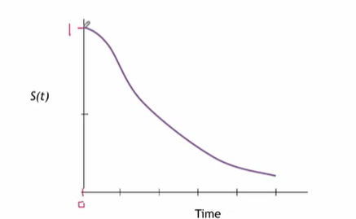

The estimated curve is S^(t) , S-hat t, is based on all subjects in the sample – censored and those who have the event

Hard to figure out the rate of the death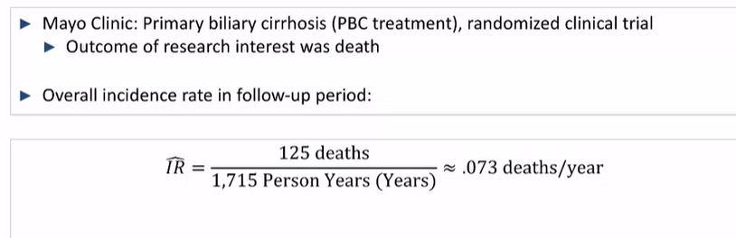

The survival curve or **Kaplan-Meier Curve** shows the propotion of events (Deaths) with time (years)

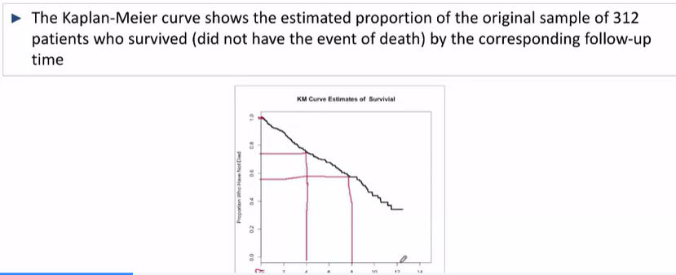

Things that can be inferred:

e.g. The significance of an event can be viewed as time goes on e.g. perhaps the event eventually tails off

-Median, time when 50 percent of the events have happened

-5hth percentile, time when 5 % of the events have happpened

For censored data:  
-Individuals lost to no-contact should be counted up to the period of no-contact

-Individuals who were unable to be followed all the way should (have their years included) up till the end of the study

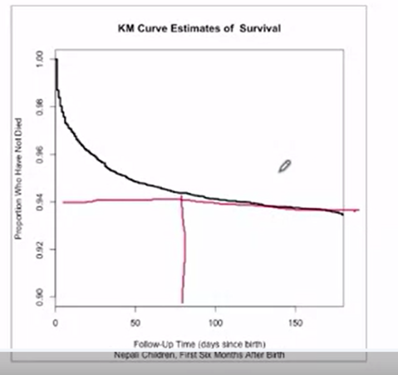

Calculation of Kaplan Meier Curves – can use both (incomplete) censored and complete data

**The curve only changes at the turn of the first event

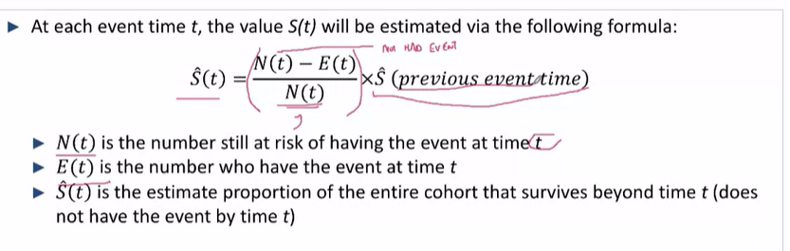

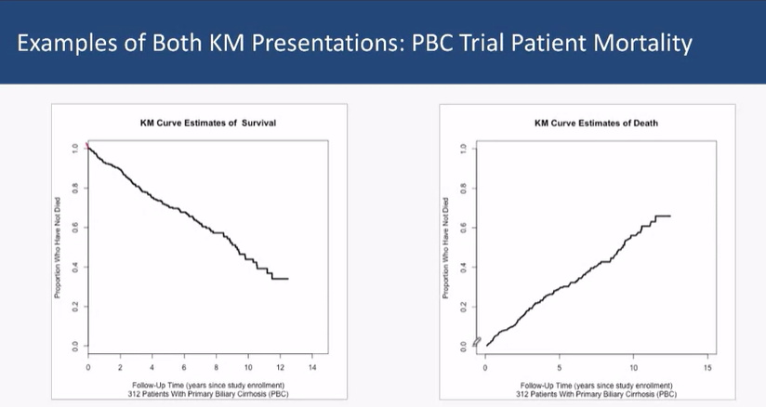** Sometimes, instead of graphing S^(t), we graph 1 – S^(t)

**Comparing Survival proportions across time**

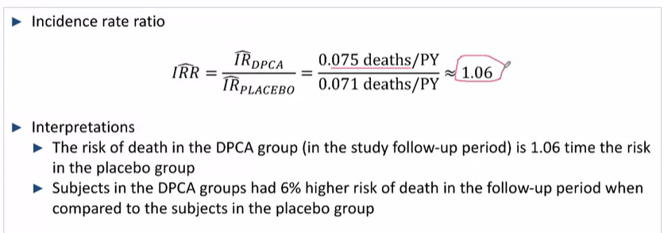

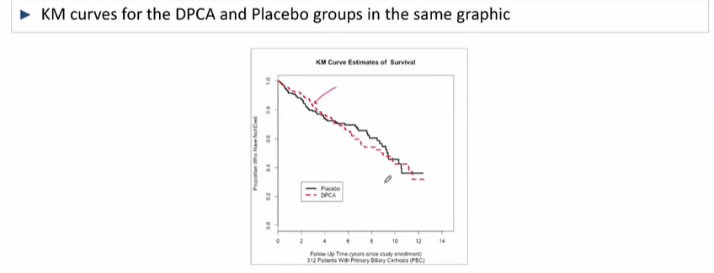

-You can present the KM curves complementarily

-You must remember that the proportions are affected by the censored data

**Sampling Distribution – a theoretical distribution**

The sampling distribution of e.g. **Sample mean weigths** of random samples -- the distribution of a statistics parameters over an infinite number of occurences (samples)

e.g. a distribution of how the sample means of the proportion of Singaporean's who have been vaccinated for the flu – the sample mean can take many different possible values, based on if we took as many different samples of 100 singaporeans to sample from

Sampling distribution of the sample mean

**E.g. estimated sampling dsitribution of MEAN heights --** each value in this historgram is the value of a sample mean, from a sample of size n=20

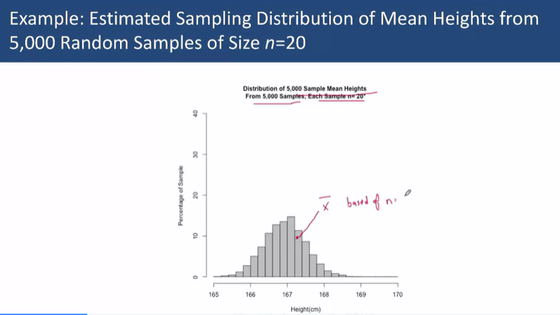

As the number ,n – the number of occurences in each sample taken increases, the variation of the sample distribution decreases

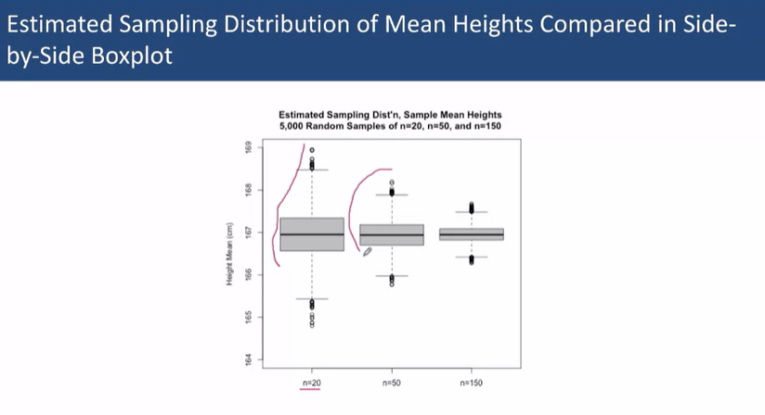

-While the distributions of the statistics might be skewed, the distribution of the samples is not

**Characteristics of sample distributions**

Can be used to estimate any statistic, incidence rate, mean etc. Etc.

Is always symmetrically distributed

Variations in sample means decreases as the means are based on larger and larger samples

Average of the sample means (regardless of the size of each sample the mean is based on) is close to the true population mean

However, the variation in sampling (values of sample means), decreases as the size of each sample that each mean is based on is increased

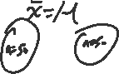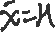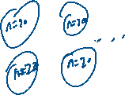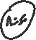

**E.g. Sampling Distributions of binary and time to event-data (incidence rate)**

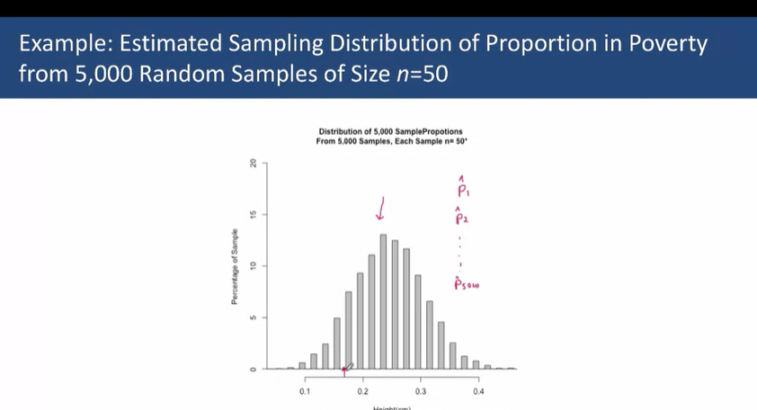

**Binary data -** Plotting the P^ (P-hats), proportion of statistics

-The distribution of proportions. P^ is bell-shaped and symmetric

-The variation of the P^s decreases as the number of individuals eacch p^ statistic is calculated from

**Sampling distributions for incidence rates**

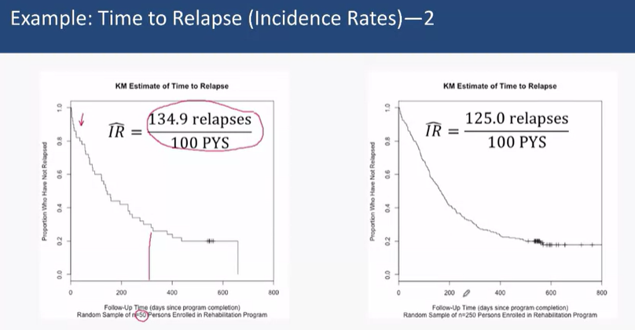**Random samples of 50 and 250 respectively**

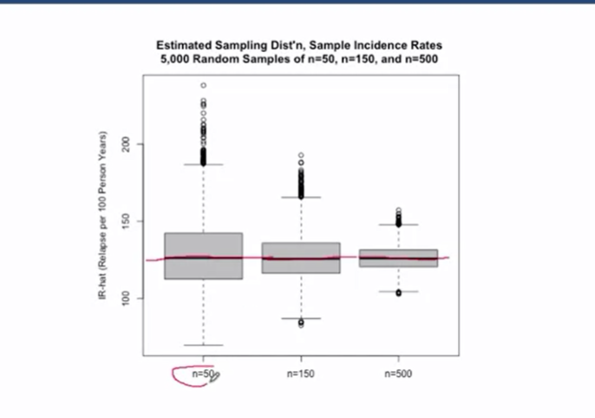The variability of the incidence rates (sample estimates) decreases as the size of each sample the estimate is based off increases

However, the average of the incidence rates(sample estimates) approximates to the true population value of Incidence rates

**Sampling distribution of sample mean**

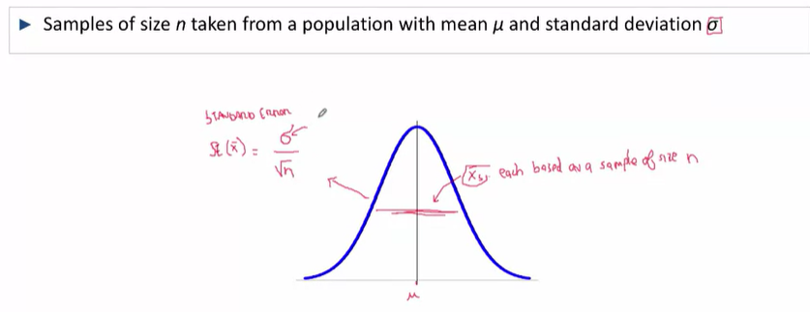-infinitely many X-bars make up the above normal distribution

By CLT, the distribution of miu, is approximately normal

But how do we calculate Standard error?  
Standard error (of means based on n = n),can be estimated using s (the standard deviation of the sample that we have calculated)

**Sampling distribution of sample proportion**

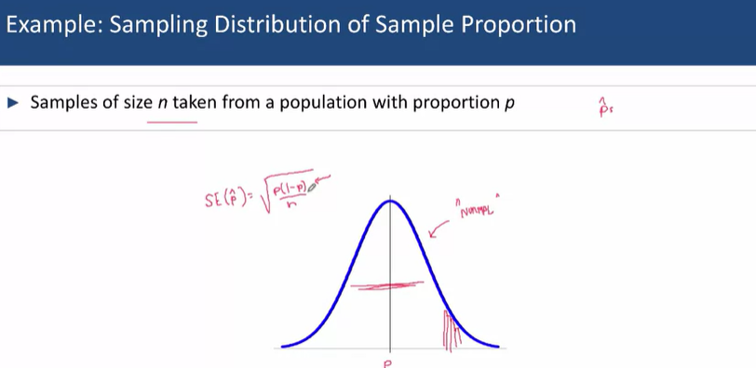

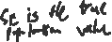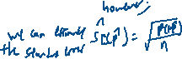

***Standard Error – the standard deviation of the summary statistic***

-yet we only have one estimate (with our sample), and it can fall anywhere under the normally distributed curve

-However, with our Estimated standard error, SE^

**-95% Confidence intervals – by +- 2 SE^s to each side of our estimated sample mean, we get an interval that contains the truth (population mean) 95 % of the time**

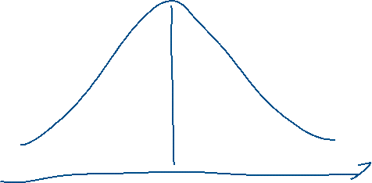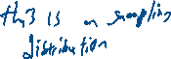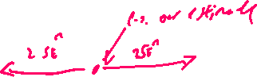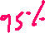

**Sampling distributions example**

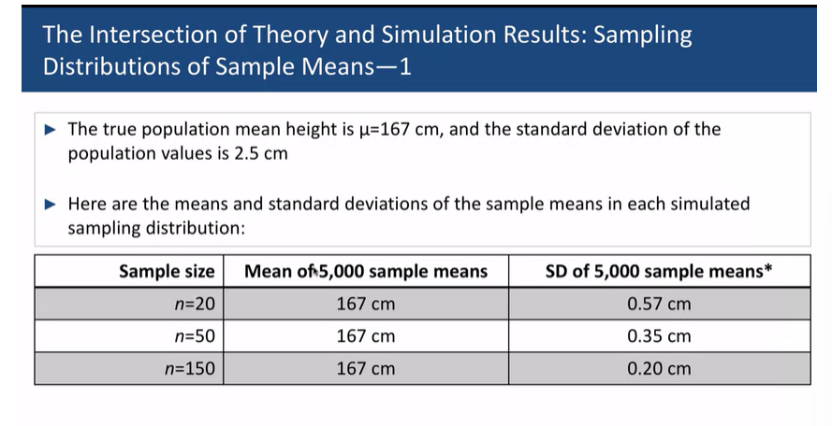-where we know the true population mean and se, we can compare the observed ariation to what would be predicted theoretically

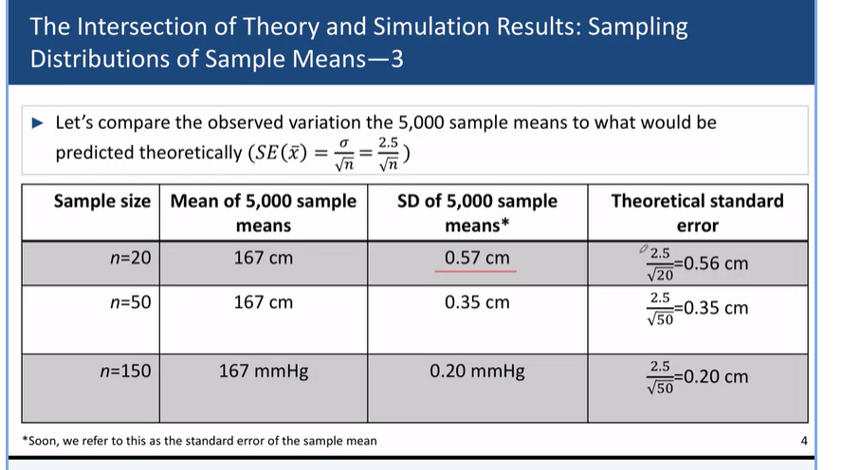

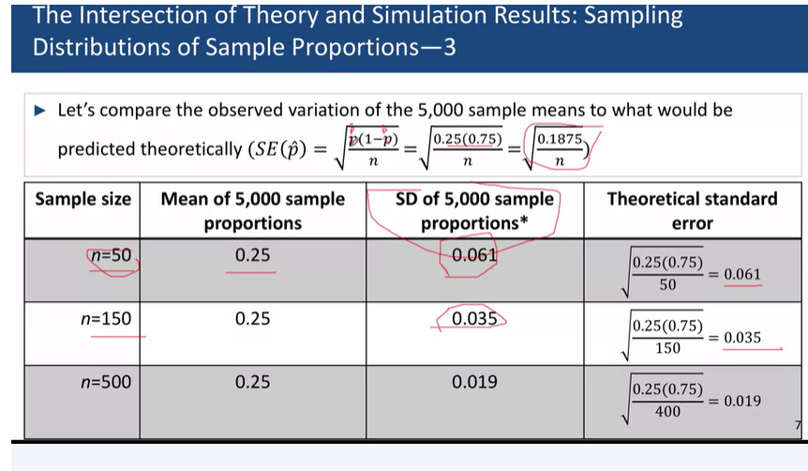

**Confidence Intervals**

**For Population Means**

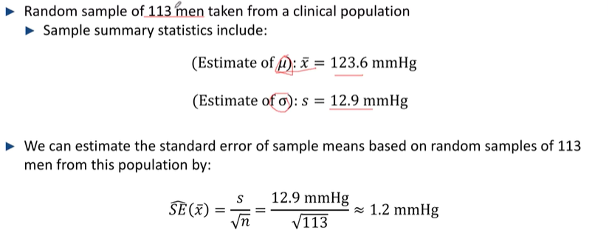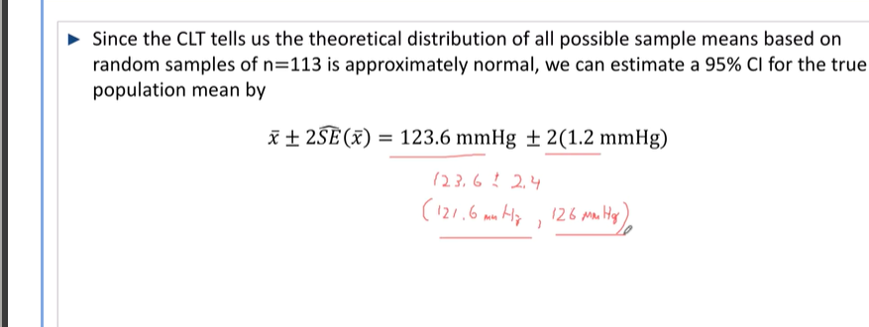

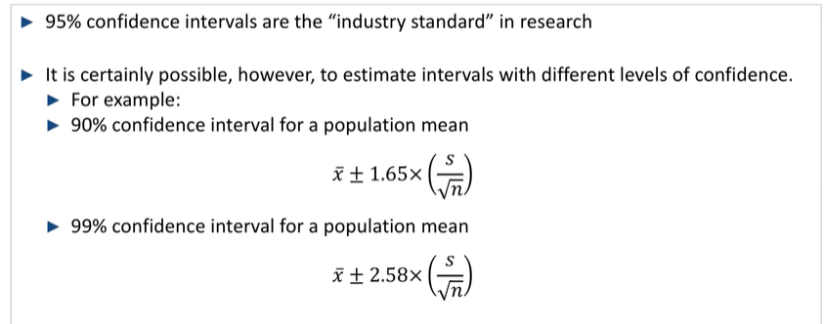

-Lower and higher confidences respectively

**What do Confidence Intervals Mean?**  
- it gives an interval for: a) the likelihood of the event occuring (P^) or b) range of means c) any other summary statistic

-When a CI is created form a sample of data, the resulting interval either incldues the value of the Unkown, true parameter, or the interval does not contain the truth

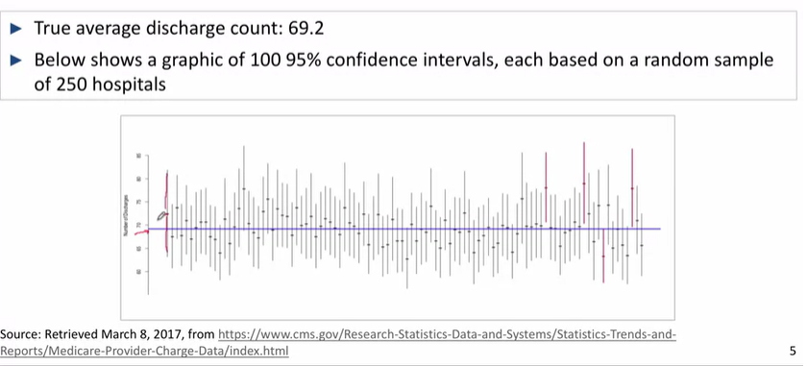-Most confidence intervals include the true value of 69.2%

-~95% of the time, the CI contains the truth, but how do we know if our CI falls into the 95% or not?

**Real life research**

The truth can never truly be observed but it works most of the time

**Confidence Intervals for Population Quantities Based on small samples**

Central Limit Theorem requires a minimum sample for the sampling distribution to be approximately normal, n = 60

* Sample needs to be large enough so that influence of any single extreme point can be negated
* The definition of “enough” differs based on the type of data: for means, n=60

**t-distribution**

If we have a smaller sample size, we will have to go out more than 2 SEs to achieve a 95% CI as it's now based on a t-distribution

-How many SEs we need to go depends on the degrees of freedom, linked to sample size

-The appropriate degrees of freedom are n-1

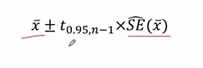

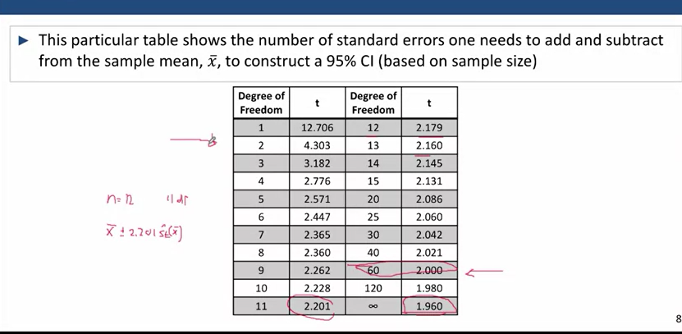

As the degrees of freedom, based upon n approaches infinity, the number of SEs that need to be added and subtracted approach +- 1.960 which refer to the number of SEs that give a valid 95% CI

The smaller the sample, the greater the number of SDs needed because there is more uncertainty regarding the actual population mean that is calculated with the means obtained from all possible samples. Thus, by increasing the number of SDs, we cover a greater range of values to give the same probability (95%) that the true population mean falls within the calculated range.

**Estimating and interpreting CIs – for 2 types of studies**

**Between Paired samples**

When 2 samples drawn from populations under study are linked systematically

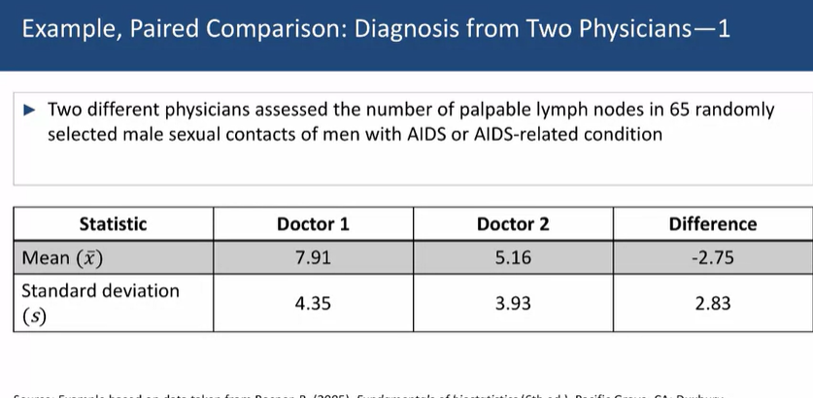

Convert the 2 different samples into a variable that measures the difference between them (65 differences in this cases) -- mean difference = (a1  - b1 + a2  - b2  .......)/n

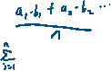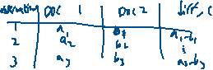

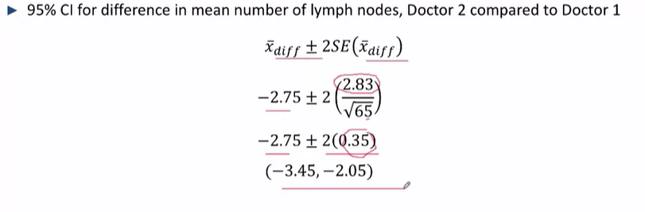

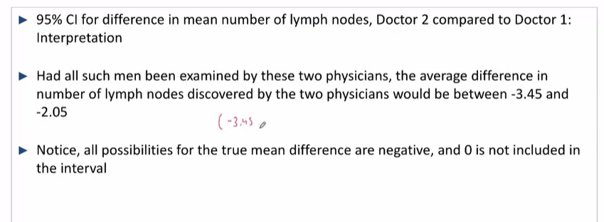

If the 95% CI of difference does not include 0, then we can say that there will always be a difference between the findings of the 2 doctors and that the method that the doctors are using is not reproducible

The resulting doctor-to-doctor differences are not fully explained by sampling variation

**Between unpaired samples**

When the 2 samples (or more) are drawn from 2 independent, unlinked populations

-For more than 2 samples, 1 can be set as a reference

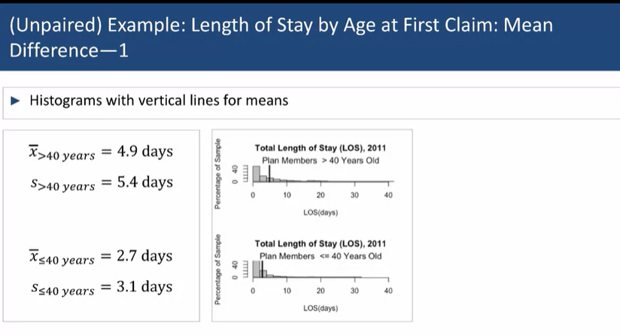

Let the data be:  
sample 1, older persons (>40yo)

N = 9000

Sample 2, younger persons(<40yo)  
N = 3000

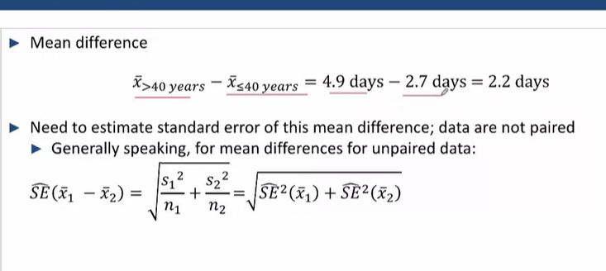



However, the estimation of the standard error is the root of the sum of the square of Se(1) and Se(2)

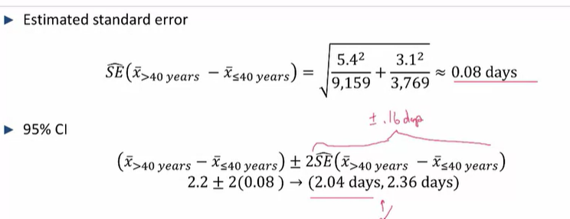

**\*\*Thus Given that the 95% CI of the mean difference does not include 0, there is a statistically significant difference between variable a and b (the lenght of stay for younger individuals as compared to older individuals**

**Confidence interval comparisons for proportions in Binary studies – Unpaired (most used)**

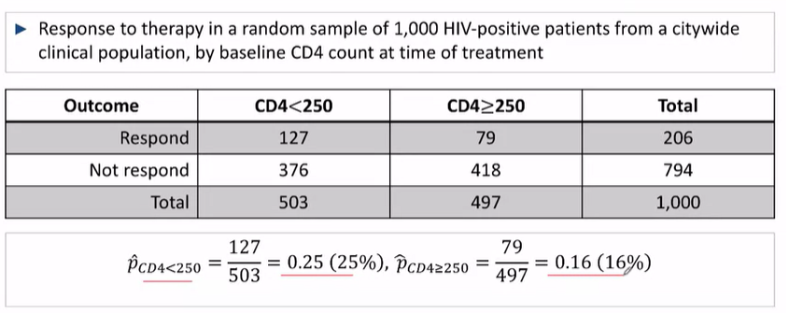

Summary Measure 1: Risk Difference, difference in proportions = 0.25-0.16 = 0.09

There was a 9% greater absolute risk to therapy in the group of CD4 < 250 as compared to the group who had CD4 counts >= 250

Resulting 95%CI follows the general form of:

Difference in proportions – 2*SE(Difference in Proportions)

Standard error fro difference in proportions is the sqrt of the sum of each standard error (similar to variance)

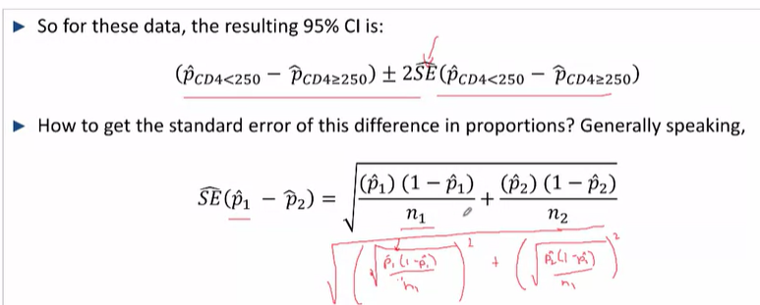



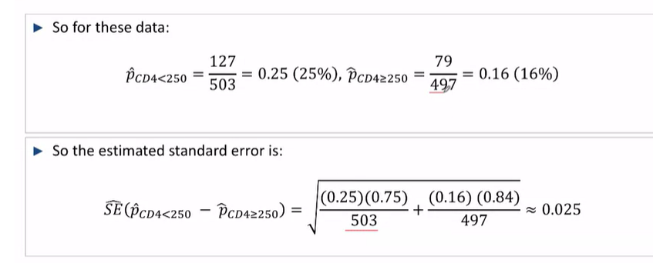

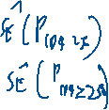

Interpretation:  
we estimated a greater (absolute) response to theraphy in CD4 < 250 group, as compared to CD4 >= 250 group

After accounting for this sample variability, this response could be between 4% and 14% greater in the population 95% CI : 0.09 +-(0.025) --> (004,0.14)

**What we’re looking for is a statistically significant difference in proportions (something that doesn’t cross 0) such that it reflects a decrease and an increase

**Ratio of Proportions and Odds Ratios**

**Log relative risk estimate**

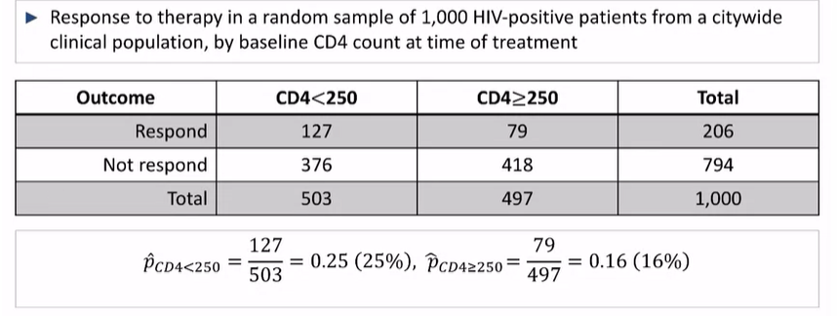

Risk Dff and 95% CI: 009 (0.04,0.14)

RR^: 0.25/0.16 = 1.56

OR^= (0.25/0.75)/(0.16/0.84) = 1.75

To get confidence ratios for the RR^, we have to use the ln scale

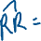

So how are we going to get the **Standard error for ln(RR^)??**

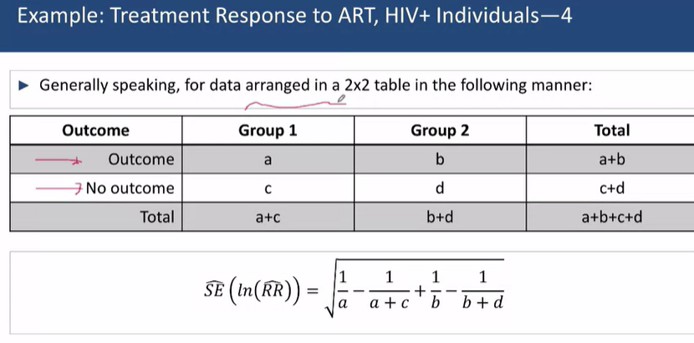

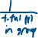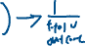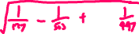

95% CI for ln(RR^) = ln(RR^) +- 2(0.13) 🡪 (0.18, 0.60)

But for the ln(RR), you realise that this interval does not include the null value for lg or ln ratios aka 0

To convert the relative risk back from ln(RR^), you just have to exponentiate the confidence intervals themselves

(e^0.18, e^0.60) 🡪 (1.20, 1.82)

RR^= 1.56 (95% CI: 1.20. 1.82)

Consequently, you realise that the CI doesn’t include the null value of RRs of 1

Based on the results of this study, HIV Positive individuals with CD counts of less than 250 at the time of starting therapy have a 56% greater risk of responding to therapy when compared to HIV-positive individuals with CD4 Counts of greater than or equal to 250 at the start of therapy

CI: Additionally, the results estimate that this increase in risk could be as small as 20% and as large as 82%

**Log odds ratio**

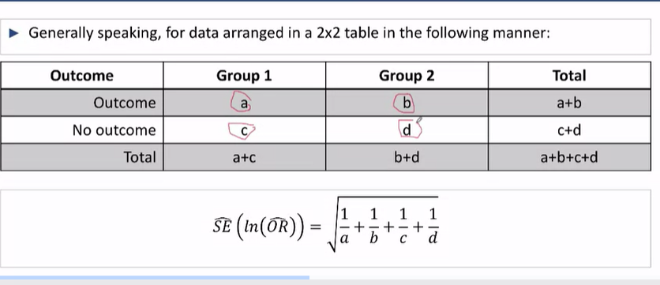

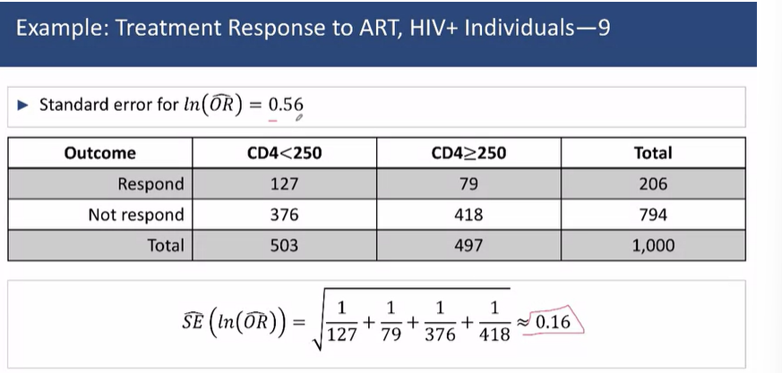

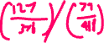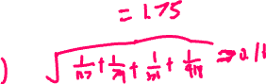

**Aways always use **ln**

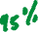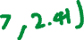

Thus, the odds ratio for HIV positive individuals who had CD4 Counts <250 initially to those who had CD4 counts >= 2t0 initially, is 1.75 (95% CI: 1.27, 2.41)  
It can be said that HIV + individuals who had CD4 counts <250 initially had a 75% chance of responding to therapy when compared to HIV positive individuals who had a CD4 count of >= 250 at the start of therapy. Additionally, the results estimate that this increase in response odds could be as small as 27% and as large as 141%

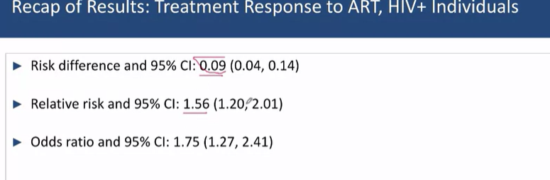



The results should be statistically significant across the 3 measures, and they should be **consistent in terms of their statistical significance**

However, statistical significance doesn’t translate to scientific significance

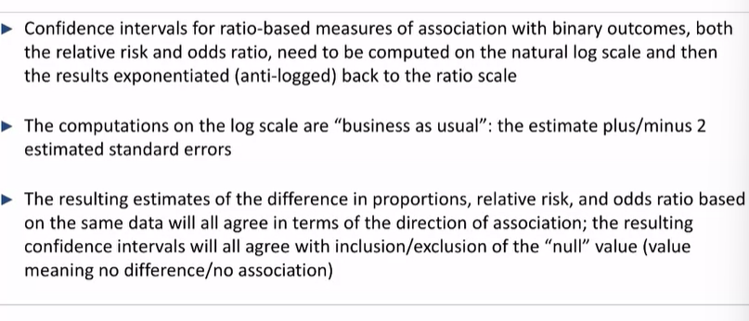

**Comparisons of Cis for Binary Studies**

Confidence intervals for:

1. Difference in Proportions
2. Relative risk
3. Odds ratio

Sould agree in in terms of including/not includingthe respective null values

**Confidence intervals for incidence rate ratios**

-Incidence rate ratio: rate at which event happens per unit time

-the 95% CI for the IRR will need to be initially done on the ln scale

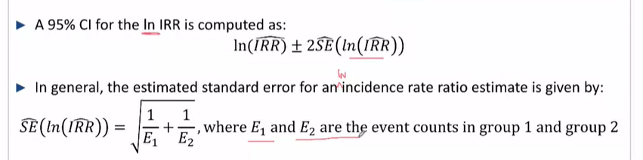

Ln(IRR^) +- 2*SE^(ln(IRR^)) = (a, b)

95% CI is given by (ea, eb)

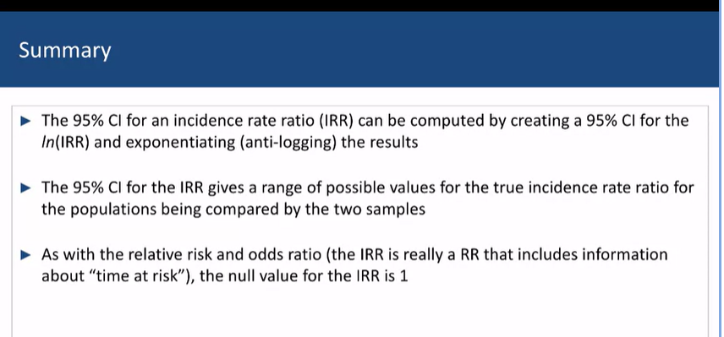

**About Ratios**

The scaling of ratios in not symmetric around the value of 1, on the log scale (ln), the values of ln(ratios) are symmetric about 0

Thus there are equally many values that are negatively and positively associated with the ratio.

this allows the scales of those values above and below 1 to be compared proportionally

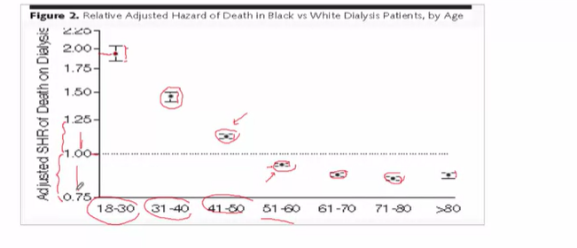

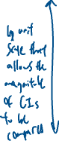

**Hypothesis testing for population testing**

In hypothesis testing there are 2 competing truths

H0: No actual difference between the 2 populations

HA: A statistically significant difference between the 2 poplations

-And these can be calculated for:

Continuous measures: They have the same mean, u

Binary measures: they have the same proportions, p^

Time-to-Event: They have the same IR

Hypothesis testing assumes that H0 is the truth, and we measure how close our result is to the truth H0, in terms of standard errors

The p-value is the probability of getting a study result as extreme as or more extreme than the null value, **by chance alone**, if H0 were the underlying population truth

Rejection level, alpha level: usually <= 0.05

**Hypothesis testing - paired study**

Paired, t-test:  
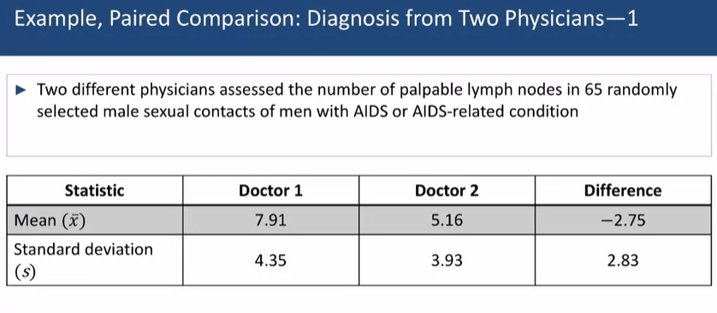

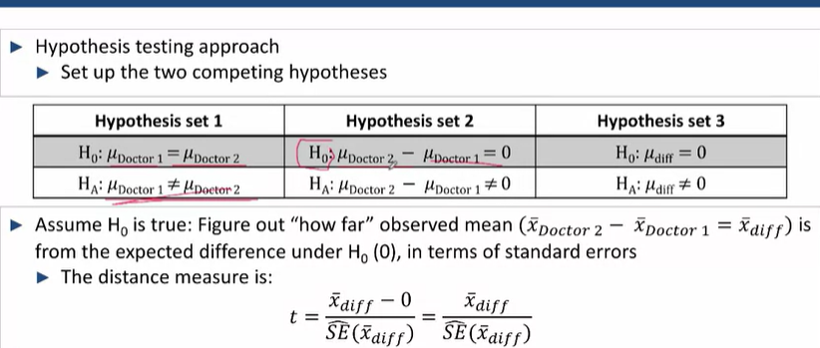

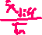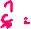

3 hypotheses that reflect the same thing – the doctors do/don’t find the same number of lymph nodes

Where t is a measure of SE^s of the variable from the supposed mean

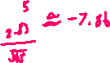

From this, we’ll calculate this SE^difference into a probability , so we appeal to the sampling distribution of xdiff

p-value = 3.84*10-15

Therefore, we reject H0 and determine that there is a difference in mean physician ratings

**This decision is consistent with the 95% confidence interval – the confidence interval and the p-value should always agree In their statistical significance**

**Unpaired – comparing means**

-Unpaired t-test, 2 sample t-test

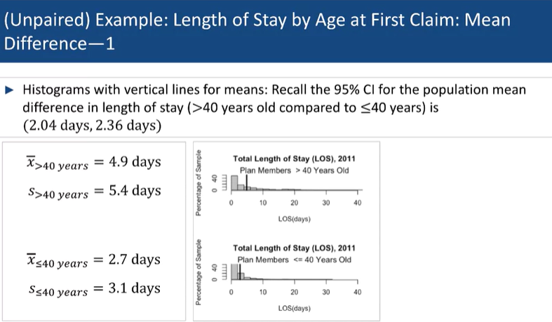



**Hypothesis**

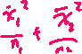

null Hypothesis H0, mean length of stay u<=40 = u>40



Alternate Hypothesis Ha, mean length of stay u<=40 =/= u>40

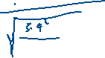

**Summary, Paired t-test v unpaired t-test**

-Vary how you calculate the SE^ of the difference in their means

-You must respect the pairing (because there is shared variability in the results in paired data, resulting in us getting inflated SE^)

**P-value**

-A P-value is a probability of obtaining the result **purely by chance alone,** assuming the **H0** is true

-P-values are always computed under the assumption that H0 is true

If the p-value is small, either:

1. A very rare event occurred under H0
2. H0 is false

So, we have to decide at a point at which we reject H0 and decide that such differences are not due purely to chance but because of an actual difference too

**Type 1 error**

Reject H0 in favour of Ha when H0 is true

The cutoff is alpha, a, the probability of a false positive (rejecting H0 when it is true)

* Thus, if the p-value is smaller than alpha, usually 0.05, we are certain that there is a less than
* 0.05 probability of rejecting H0 when it’s true (i.e. observing results as extreme as or more extreme than the results obtained in our sample)
* We need to assign power to the study, which refers to it’s ability to find a difference

**Type 2 error**

Not-rejecting H0 when H0 is false

Beta, b, is the cutoff for preventing false negatives (1 – alpha)

**Statistical significance**

-Are not necessarily Scientifically important, even if causation can be established

-The difference in the magnitude of means is difference (which determines if it’s scientifically important)

**Unpaired Comparison, 3 groups**

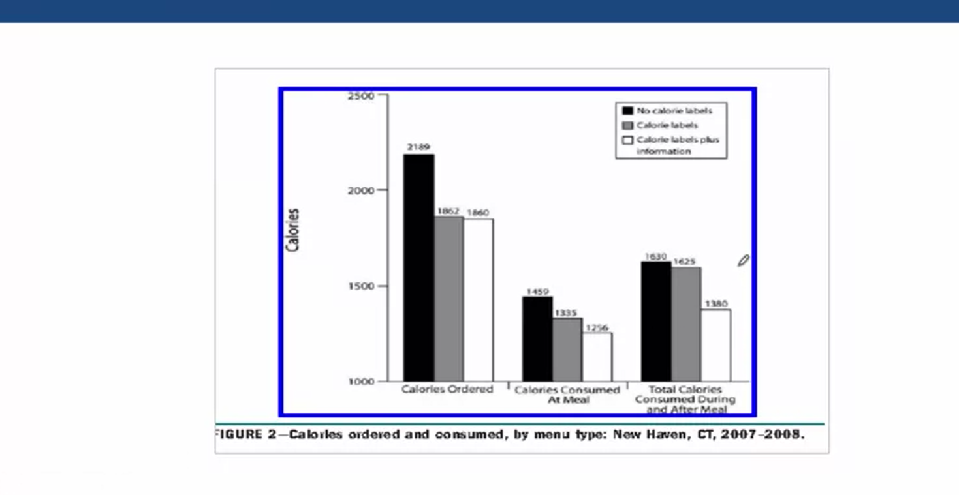

-Designate the no calorie labels as the reference, and compare labels and labels+info against it

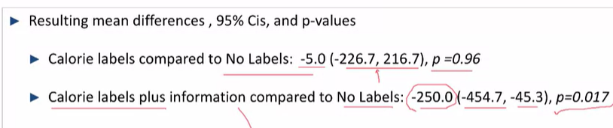

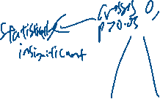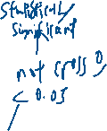

H0: ulabels+info=unolabel _

Ha: ulabels+info=/= unolabel

**Hypothesis tests**

All Hypothesis tests are just a variation of the following tests

-Establish H0 and Ha

-Assume H0 is true

-Ascertain whether it’s likely to happen or not when H0 is true

**Binary Population**

**Comparing Proportions between 2 populations – 2 sample z-test**

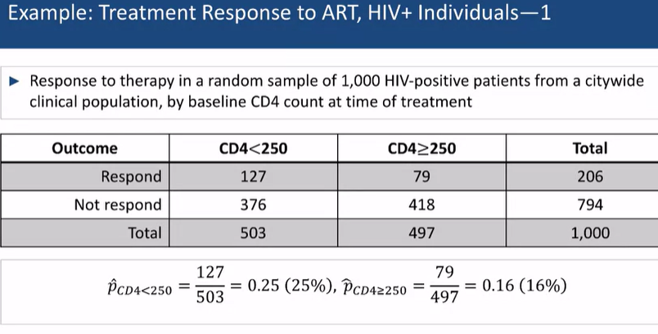

H0: PCD4 < 250 = PCD4 >= 250 ; HA: PCD4 < 250 =/= PCD4 >= 250

This can be extrapolated to Risk difference, = 0 or not, Relative risk = 1 or not. Odds ratio = 1 or not

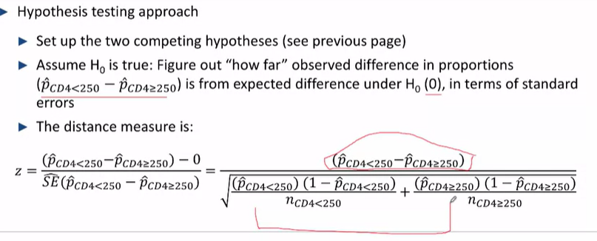



**The same formula is used:** diff / standard errors



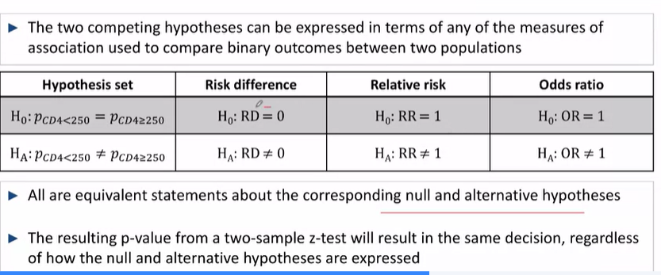

Thus, as long as the P-value for one of the hypotheses reflects a rejection/failure to reject, then it is true for the rest of the hypotheses as well

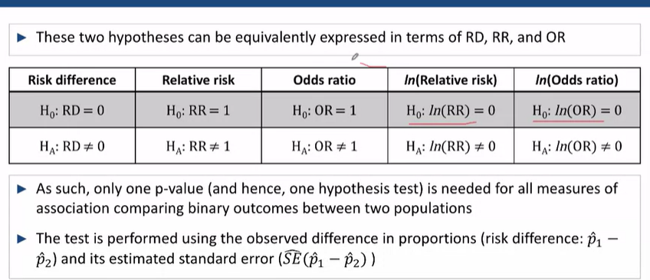

**Chi-Squared test – expanded Z-test**

***Basically analyses whether the binary distribution we have a statistically significant difference from what we would have if the binary distribution gave us our expected values***

-Comparing binary (categorical) outcomes across 2 or more populations

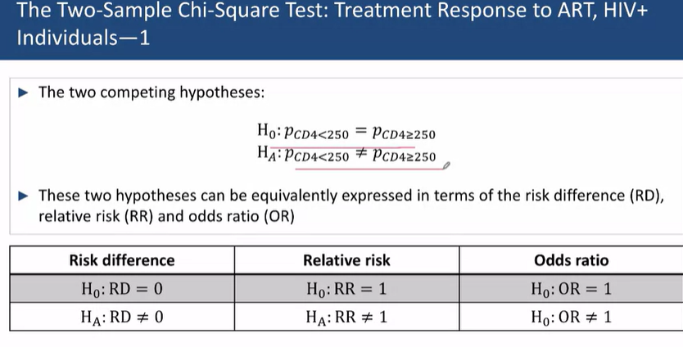

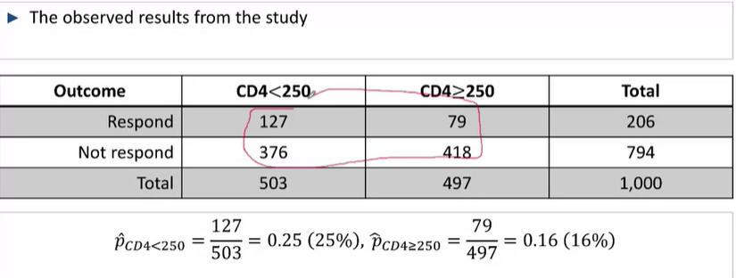

-The chi-squared test converts another table of the same size, where each cell measures the **expected (totalx * totally)** number of people in that cell, according to the following: (

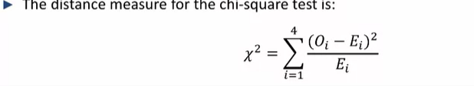

Compare the resulting p-value to a chi-sqaured distribution for the resulting degrees of freedom – for 1 degree of freedom, it is the standard normal distribution squared

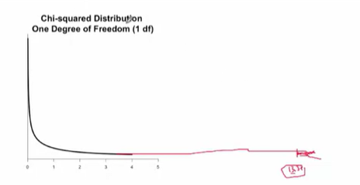

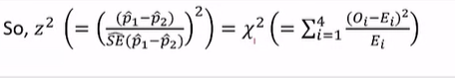

**Fischer’s exact test – can be used regardless of sample test**

-Generally, gives the same result as the 2 sampled z and chi squared except **for small samples**

-Calculates the probability, from a sample of 500, of a = 127 and blue = 373 – under the null hypothesis (probability of exact study results, given a true H0)

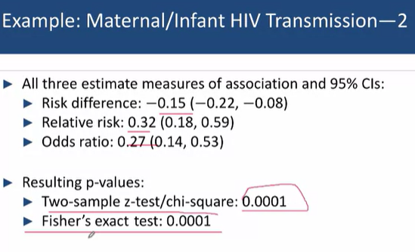

**All point in the same direction (that there is indeed a difference in the HIV transmission to the AZT group and that there is a statistically significant lower proportion of individuals receiving AZT contracting HIV**

**Hypothesis Tests for Comparing incidence rates between 2 populations – two-sample z-test**

Example – rates of lung ancer diagnosis

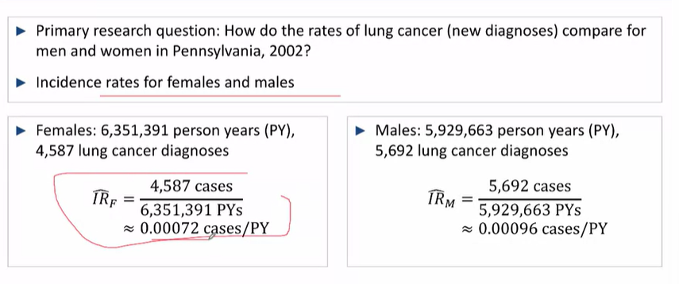

IRR^ = 0.00072/0.00096 = 0.75

Ln(IRR^) = ln(0.75)

SE^(ln0.75) = Sqrt( 1/4587 + 1/5692)

95% CI for ln(IRR^) = ln(0.75) +- 2 SE^(IRR^) = (-0.327, -0.248)

95% CI for IRR^= 0.75 (0.72, 0.78)

**must start on a ln scale

Conduct a 2 sample z-test for IRRs

Hypothesis, IR1  = IR2

Measure the distance between ln(IRR^) and 0 in terms of SEs (if there were no difference, ln IRR = 0)

Z = ln(IRR^) / SE(ln(IRR^)) = -14.5

Thus, as the p value <<< 0.05, we can reject H0 in favour of the alternative hypothesis and conclude that there is indeed a statistically significant difference in the Incidence rates of Men and women

**Comparing the IRs when there is censored data – Log-Rank test**

-contains event and censoring times

-Compares the competing hypothesis, in terms of their underlying population survival curves

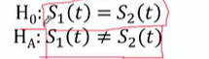

-Log-rank test: compares the distance between the Kaplan Meier curves in two samples, against 0 (if they were ideally the same), to get a p-value

-Compares the number of events observed at each time against the number of expected events

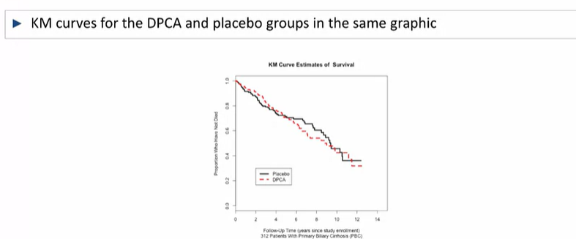

-The total, aggregated discrepancy – distance between what is observed in the samples – is compared to the distribution of such discrepnacies across samples of the same size, when the null is true

- 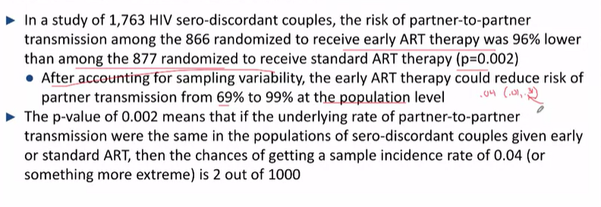

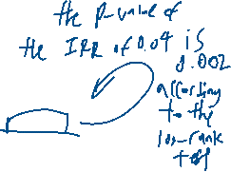

**Summary, 2 sample z vs log rank**

-interpreting the p value of the log-rank test

-2 sample z-test vs log-rank

-IR1/IR2  vs Changing incidence rates over time

-assumes the incidence rates are constant vs assumes the incidence rates change

-log-rank can be used to identify differences in the Kaplan-Meier curve

**Debriefing the p-value**

2-sded hypothesis are more often use than the 1-sided tests because they don’t result in false statistically significant values

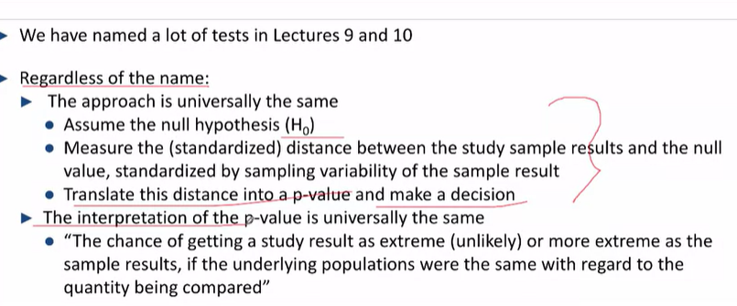

**Examples**

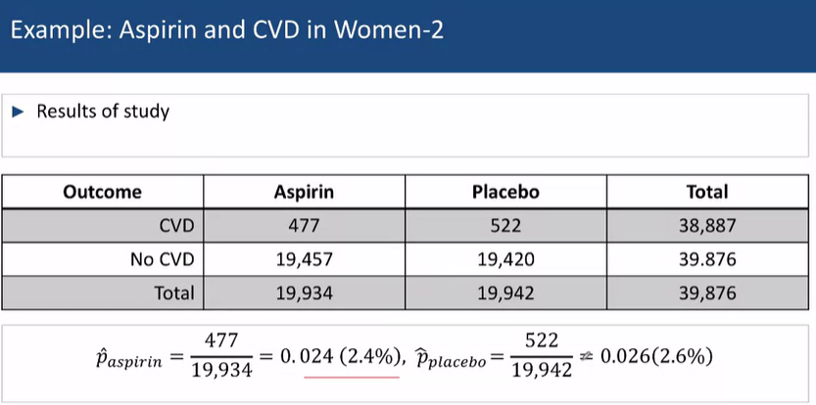

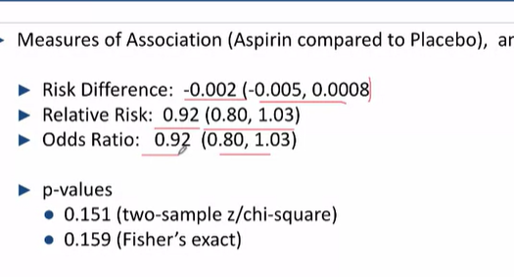

-results are not statistically significant given, Cis included the null values and the p-values > 0.05

-Particularly because this was a large study, the study had a great amount of power to reject the idea that there was a significant difference in administering Aspirin on the development of cardiovascular disease

**Comparison tests**

 For comparing the following variables:

|  |  |  |
| --- | --- | --- |
| Means | Proportions | Time-to-event outcomes |
| Paired: paired t-test  Unpaired: 2 sample t test | 2 sampled Z-test  Chi-squared  Fischer’s exact test | IRR: 2 sample z-test  Comparing across time: log-rank test |

**Comparing between more than 2 Populations**

Hypothesis test we have considered for comparing 2 populations can be extended to compare more populations

-Comparing means of multiple populations

-means: ANOVA, extended 2 sampled t-tests

-proportions: extended chi-sqare

-incidence rates/survival curves: log rank test can be extended

**Anova – comparing means for n>2**

-The competing hypotheses are:

H0: u1 = u2 = …. Un

HA: at least 2 populations have different means (u)

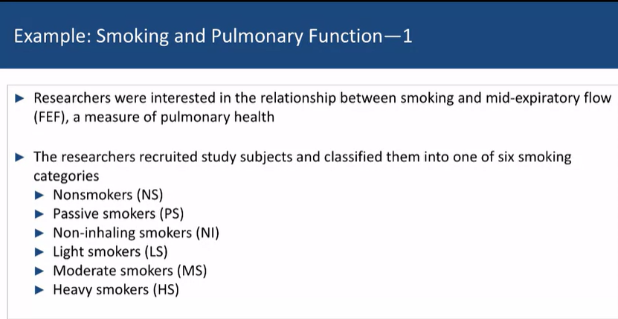

To study how smoking impacted mid-expiratory flow (6 underlying populations)

Aims:

To identify whether there were any statistically significant differences in pulmonary outcomes between the 6 underlying populations

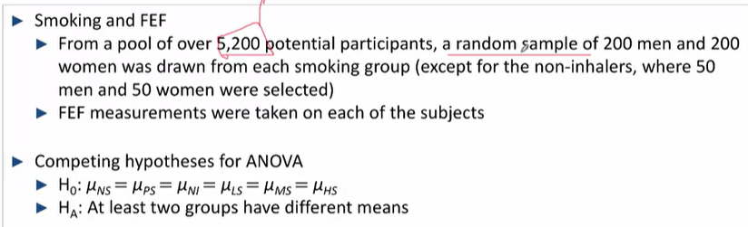

-Assume H0 is true

-Compute a measure of discrepancy between what was observed in the sample compared to what is expected under H0 (the F-statistic, derived from the F distribution)

Compare the F-statistic, the measure of discrepancy, against the expected discrepancy when H0 is true

-Convert to a p-value

-If statistics are statistically significant, p < 0.05, you can conclude that at least 2 means are different

-From there, you can run individual comparisons to determine their relationships

**Chi-Squared – comparing proportions for n >2**

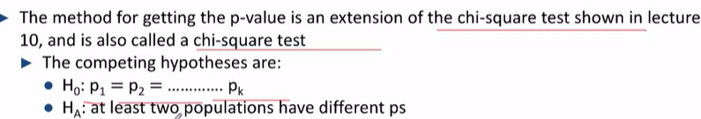

-Degrees of freedom depend on how many populations are being compared

E.g. how the lack of health insurance is related to one’s citizenship and birth

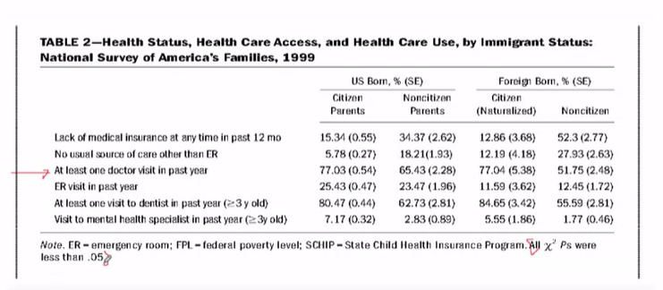

H0: p1=p2=p3=p4 aka there is no difference in individuals who had lacked health insurance (in the previous 12 months) based on their birthplace and citizenship

Ha: at least 2 of the populations had different Ps

-Expected vs observed table is constructed

-Chi squared test statistic is calculated

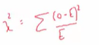

-Compared against the chi-squared distribution for the respective degrees of freedom

-obtain P-value

E.g. Comparing differences between Male and female physicians

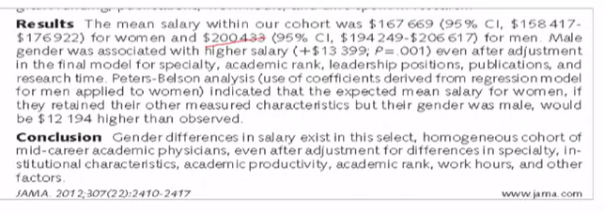

-How do you decide what to adjust for?

-In affect to affect the r/s between sex and pay, the characteristic had to be associated with both the sex and pay

-Look for the correlation between race and gender, mean age and gender, children and sex, marital status and gender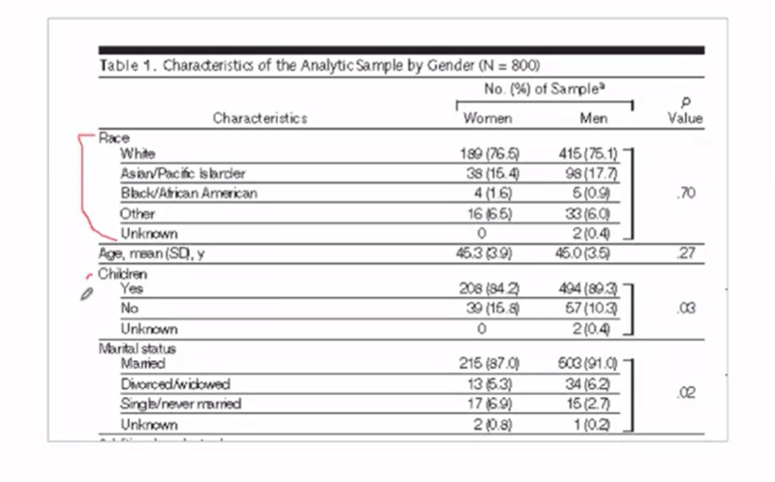

**Log Rank Test – comparing Survival Curves for n >2**

-Can only be done when we have individual tim-to event data, not just rate

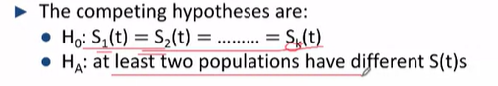

Same v diff survival curves

Example: Maternal supplementation and infant mortality

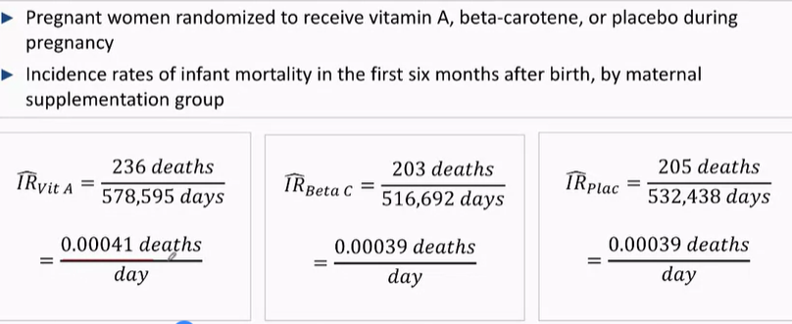

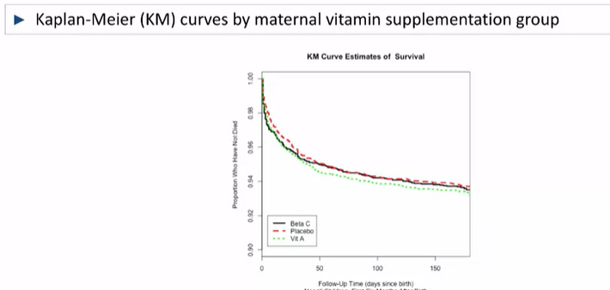

To calculate if there is a difference in the incidence rates of the 3, designate the placebo to be the reference. And calculate the respective IRRs from there 🡪 using the ln scale

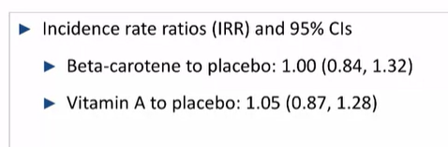

The Log-rank test tests all 3

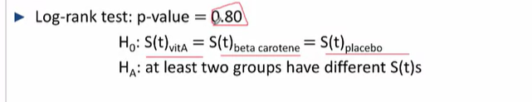

Thus, there is no statistically significant difference between the 3 survival curves at the population levels

**Procedures for comparing multiple populations with one test**

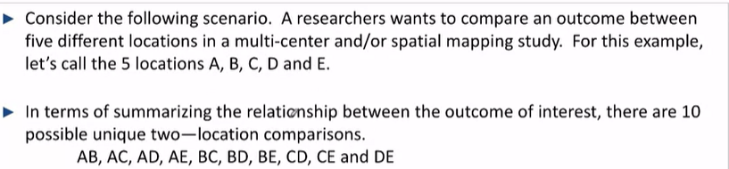

-There are much less combinations of test statistics and Cis that have to be dealt with than if we were comparing all statistics within themselves by using a reference group

-it is possible that none of these comparisons are statistically significant, but there are a statistically significant difference(s) for other comparisons

-The overall p-value test allows the reader to ascertain that there are no differences overall – and protects from missing a difference

e.g. for variable A,B,C,D,E

In ascertaining that there is nothing that affects A,

We could have tested for AB and AC but we might miss statistically significant comparisons that would be revealed with comparing for multiple things

**Multiple Comparisons Corrections**

-When comparing outcomes between >2 populations, the number of unique population subsets >1

When comparing 3 populations, there are 3 unique 2 pop subgroups

AB, AC and BC

4 populations, 6 unique 2 groups

5 populations, 10 unique 2 groups

….

After comparing using an overall test, sometimes the subsequent 2 population comparisons will be adjusted for multiple comparisons

-You found an overall diff and now you go comparing individual groups of 2 to find the differences

**Different tests scenarios – to evaluate if all the combinations are true**

By performing One test:

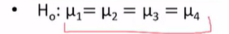



By performing all possible comparisons (2 sample t-tests or any other 2 sample tests) 

-If alpha level = 0.05, so the chance of not rejecting the null if it is true = (1-a)^n

= 0.95^6 (6 combinations) = 0.74 – Doing the right thing and not rejecting any of the tests

-The chance of making a false positive = 1-0.74 = 0.26 (this is much higher than the 5%) – because each of them has a chance of being rejected when it is true

**So what can be done to preserve the 5%**

-The overall test is performed with an alpha level of 0.05

-Subsequent 2 population comparisons to find specifically which populatiosn have different (means, proportions, etc.) are evaluated at a more stringent alpha level – **so as to maintain an overall alpha level of 0.05**

-e.g. Bonferroni correction:

-new alpha: original alpha level / (number of combinations being tested)

**So should the results be interpreted differently?**

Should the results be interpreted differently if one only looked at a single unqiue 2 sample comparison v looking for any differences? (cause then you have to take into account that the alpha level you’re looking for results at is diff)

-it is ignored in more complex analyses in multiple regression

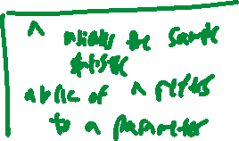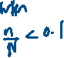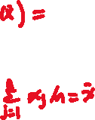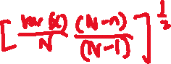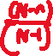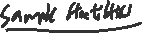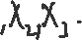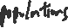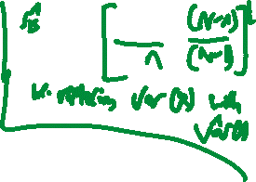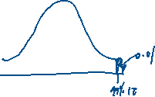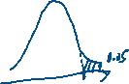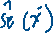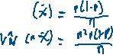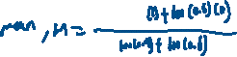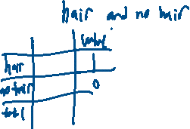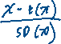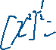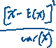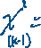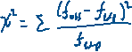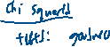

Testing for continuous outcomes:  
paired

Unpaired

Testing binary outcomes, incidence rates, time to event:  
unpaired

Confidence intervals 🡪 creates an interval that (likely) includes the unknown truth for the population comparison measure